Analysis of Customer Purchase Patterns Using WEKA
A Comparative Study
Name:K.Tejsavini
Rollno:20241CSD3002
Abstract
This study analyzes a retail dataset of 1,000 customer transactions with 20 attributes covering demographics, product details, and transactional behavior. Using WEKA, various machine learning algorithms were applied to uncover purchasing patterns, classify customer segments, and identify associations between product categories and customer traits. Algorithms such as Naïve Bayes, J48 Decision Tree, Random Forest, K-Means Clustering, and Apriori Association Rule Mining were used. The findings aim to support smarter marketing, inventory planning, and personalized customer engagement.
1. Introduction
Retail businesses generate vast amounts of data daily. Hidden within this data are insights into customer behavior, preferences, and decision-making patterns. This study uses WEKA to mine a structured retail dataset and apply classification, clustering, and association rule mining to discover trends in customer purchases.
Objectives:
To evaluate the performance of different classification algorithms (e.g., J48, Naïve Bayes, Random Forest) on retail customer data. To identify key attributes that influence customer purchase frequency and spending behavior.
To segment customers into meaningful clusters based on demographic and transactional features.
To visualize class distributions and cluster patterns using WEKA’s built-in tools.
To assess the interpretability and complexity of models for practical deployment in retail analytics.
To discover hidden associations between product categories, seasons, and payment methods using Apriori.
To compare baseline models (e.g., ZeroR) with advanced classifiers to highlight predictive improvement
2. Dataset Description
The dataset contains 1,000 instances and 20 attributes. It includes both numeric and nominal features such as:
S.No | Attribute | Description | Type
1 | Customer ID | Unique identifier | Numeric
2 | Age | Age of customer | Numeric
3 | Gender | Male/Female | Nominal
4 | Item Purchased | Product name | Nominal
5 | Category | Product category | Nominal
6 | Purchase Amount (₹) | Total amount spent | Numeric
7 | Location | City or region | Nominal
8 | Size | Product size (S, M, L, XL) | Nominal
9 | Color | Product color | Nominal
10 | Season | Season of purchase | Nominal
11 | Review Rating | Customer rating (1–5) | Numeric
12 | Subscription Status | Subscribed to offers (Yes/No) | Nominal
13 | Shipping Type | Standard/Express | Nominal
14 | Discount Applied | Whether discount was used | Nominal
15 | Promo Code Used | Promo code usage | Nominal
16 | Previous Purchases | Count of past purchases | Numeric
17 | Payment Method | Credit Card, UPI, Cash, etc. | Nominal
18 | Frequency of Purchases | Weekly, Monthly, Quarterly, etc. | Nominal
19 | Loyalty Score | Derived score based on repeat behavior | Numeric
20 | Class Label | Target label for classification | Nominal
Preprocessing Steps:
- Handled missing values using ReplaceMissingValues.
- Normalized numeric attributes.
- Converted categorical attributes using NominalToBinary where needed.
The dataset was preprocessed using WEKA filters including ReplaceMissingValues to address incomplete entries and Normalize to scale numeric attributes uniformly. These steps ensured data consistency and quality, making the dataset suitable for applying machine learning algorithms such as classification, clustering, and association rule mining.

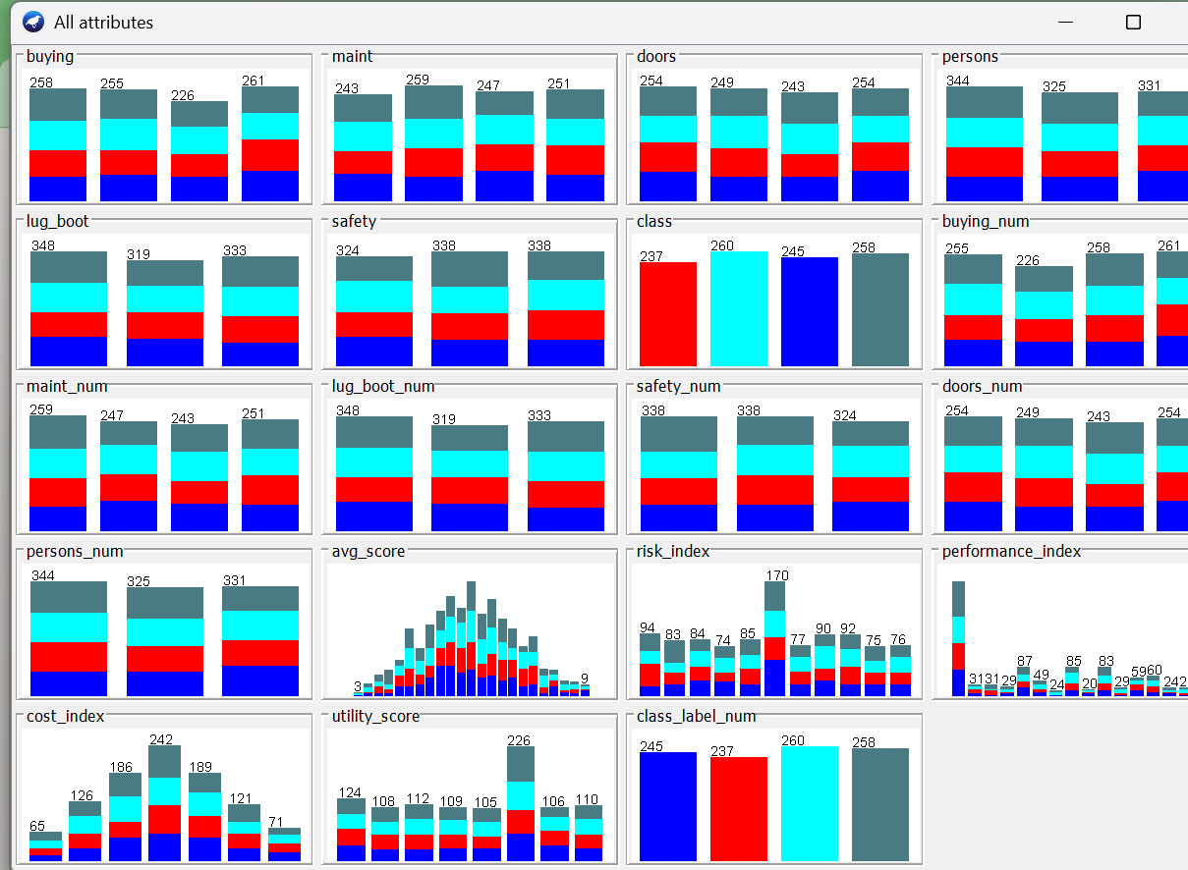

3. Methodology
Data Mining Architecture
- Data Collection: Retail dataset with 1,000 instances.
- Preprocessing: Cleaned and normalized using WEKA filters.
- Attribute Selection: Key features selected using CfsSubsetEval and BestFirst.
- Model Building: Applied classification, clustering, and association rule algorithms.
- Evaluation: Compared models using accuracy, ROC, and interpretability.
- Result Analysis: Extracted insights on customer behavior.
The dataset was cleaned using WEKA filters like ReplaceMissingValues and Normalize, followed by attribute selection and feature engineering. Classification models were evaluated with cross-validation, clustering grouped customers by behavior, and Apriori revealed key product-demographic links.

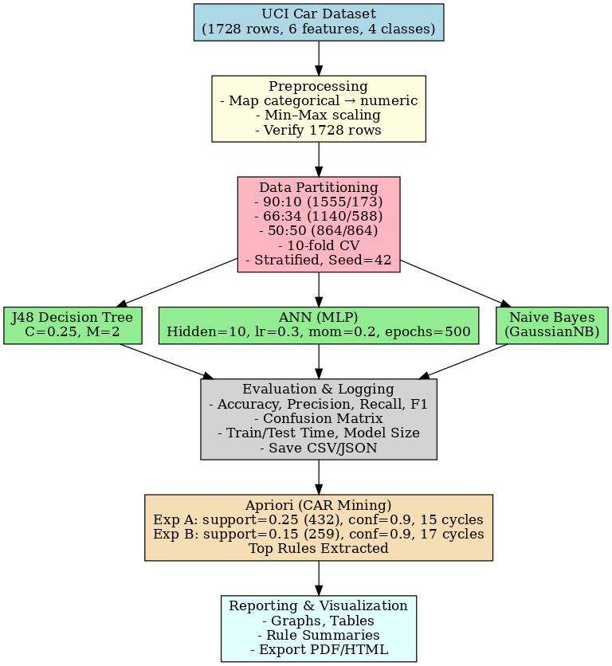

Algorithms Used:
- J48 Decision Tree – Builds decision trees using attribute splits for interpretable classification. Ideal for understanding customer decision paths.
- Naïve Bayes – Applies Bayes’ theorem for fast, probabilistic classification. Works well with categorical retail data.
- Random Forest – Combines multiple decision trees to improve accuracy and reduce overfitting. Suitable for complex datasets.
- K-Means Clustering – Groups customers into clusters based on attribute similarity. Useful for segmentation and targeting.
- Apriori Algorithm – Extracts frequent itemsets and strong association rules. Reveals hidden patterns in customer behavior.

